I can request food, things or social games e.g. peek-a-boo, chase, tickle, rough and tumble (JA) by reaching, looking at things or making sounds when my partners entice me with developmentally appropriate hands-on activities (LS) like cause-effect, building, cooking, messy play, music and art and encourage my initiations by giving me a lot of chances to communicate (IS).
I can use giving or pointing gestures (SU) when my partners offer me choices of desired objects in see-through containers (LS) and respond to my nonverbal signals to foster my sense of competence (IS). When I am first starting out, my partners might respond to my preference by following just my gaze and then when I touch, point or give the item to them.

Social Communication Outcomes
JA – Joint Attention – Why I am communicating
SU – Symbol Use – How I am communicating

Definition of partner: mom, dad, teacher & peer

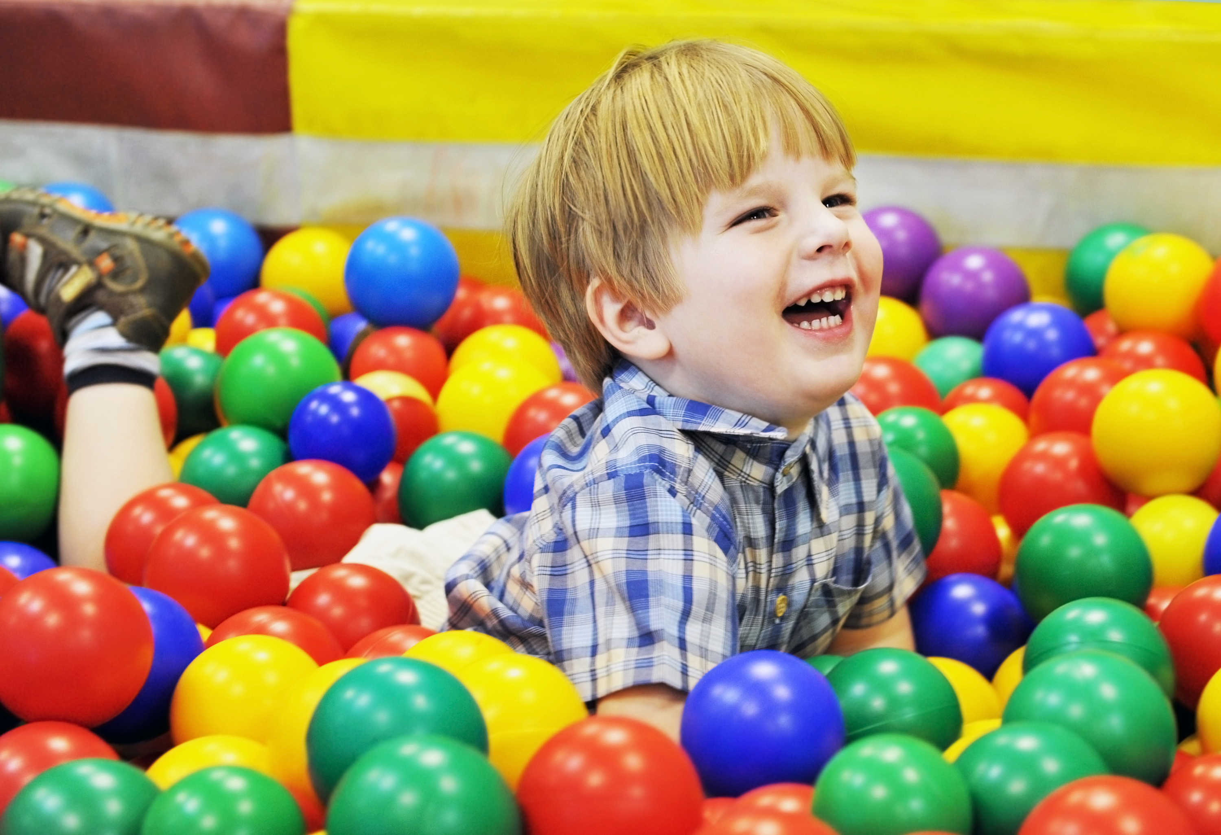

I can express emotion to seek comfort or engagement (MR) and choose coping strategies (e.g., squeezing hands or jumping) (MR) when my partners recognize my signals and offer support (IS) and teach by doing and/or say how to respond when I show stressed behavior (IS)

I can use behavior (e.g., holding an object from upcoming activity) to make a transition between activities on my own (SR) and behavior to keep myself calm and focus myself (SR) when my partners give me concrete objects to hold related to upcoming activities (LS) and provide access to materials that help calm and focused (LS).

Emotional Regulation Outcomes
MR – Mutual Regulation – How I cope with others’ help
SR – Self Regulation – How I am coping on my own
Transactional Support – What my partners do to help
IS – Interpersonal Support – How my partners change their communication for me
LS – Learning Support – How my environment can be changed to help me
Refer to Frequently Used Goals & Supports

Copyright 2017 – Permission granted for use of materials for educational purposes.

