I can use my language for greetings, turn taking, calling out for others (JA) and I can listen and speak to people about something by providing information about immediate, past and future events (JA) when my partners provide motivating topics (LS) and visuals (LS) for success in group activities.
I can use a variety of sentences to engage with my partners and I can use typical social behavior by having an awareness of personal space use appropriate vocal volume and intonation (SU) when my partners provide visuals for understanding social norms (LS) and provide guidance and visuals for understanding what others might be thinking.

Social Communication Outcomes
JA – Joint Attention – Why I am communicating
SU – Symbol Use – How I am communicating
Definition of partner: mom, dad, teacher & peer

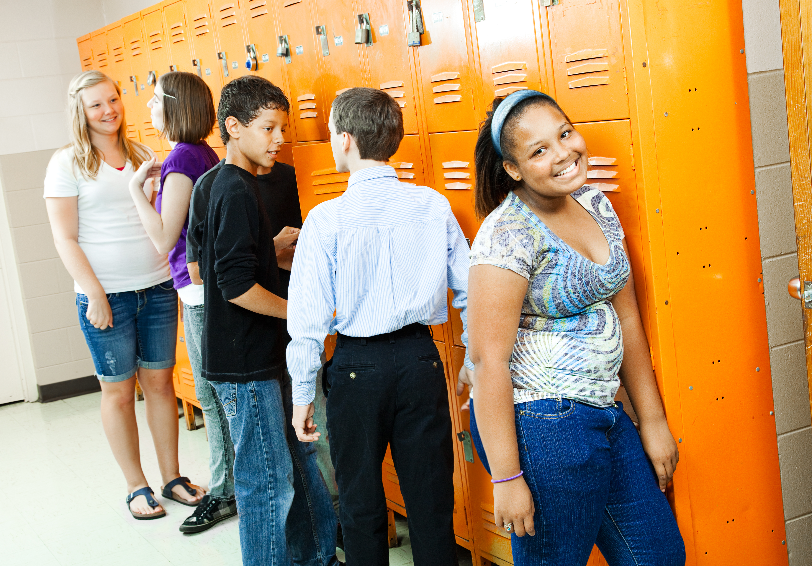
I can use my language to ask for help from others (e.g., help with activity, breaks, and other coping strategies) (MR) when my partners give me visuals (LS) and model language to help me understand how I feel, negotiation, and coping when feeling stressed and overwhelmed (IS).

I can use my language to work out and think about coping strategies (SR) that may be helpful in future situations (e.g., writing out the steps of a task, asking for help, collaborating with others) when my partners give me visuals to define steps within each task (LS) and teach and show me appropriate coping strategies (IS) e.g. asking for a break, taking a deep breath, squeezing hands.

Emotional Regulation Outcomes
MR – Mutual Regulation – How I cope with others’ help
SR – Self Regulation – How I am coping on my own
Transactional Support – What my partners do to help
IS – Interpersonal Support – How my partners change their communication for me
LS – Learning Support – How my environment can be changed to help me
Refer to Frequently Used Outcomes & Supports

Copyright 2017 – Permission granted for educational purposes

