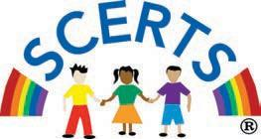

SCERTS in Action | FOCUS – Foundation Of Clear, Useful Summary

Learner: Date:
Location: Observers:
Activities Observed:
Social Communication (SC) |  | Transactional Supports for SC
Joint Attention; Why  to meet needs,  to share attention,  to engage socially,  to share experiences  to express emotions | Symbol Use; How  imitate actions/words,  gestures,  gaze,  vocal,  verbal  other symbols | Interpersonal Support  interactive style modifications  responsive  foster initiation  respect independence  developmentally sensible  modify language  model | Learning Support  activity and environmental modifications  clear structure  augmentative communication  visual and organizational support
Emotional Regulation (ER) |  | Transactional Supports for ER
Mutual Regulation; With Others  respond to assistance offered  seek assistance from others | Self-Regulation; On Their Own  sensory motor behaviors,  information/ language strategies  metacognitive/ reflective strategies | Interpersonal Support  interactive style modifications  responsive  foster initiation  respect independence  developmentally sensible  modify language  model | Learning Support  activity and environmental modifications  clear structure  augmentative communication  visual and organizational support

