Water Safety Lesson Plan 9 Safety Signs - PSHE
Y5 WATER SAFETY – Lesson 9 Safety Signs - PSHE
Walt: know how to avoid dangers  Wilf:  - explain why we need signs and signals to keep us safe  - know all the safety flags  - know some of the safety signs | Teaching Points/ Resources  ‘Swim Safe’ pp  Know Safety Signs pp  4 colours of signs word doc  ‘Swim Safe’ Activity sheets p3, p4, p5 (and answers)  Safety Signs at the Beach sheet  Safety Signs Quiz
Introduction – lots of exciting places to go. Recap on flags using Swim Safe powerpoint slides 1-7. Ask if anyone noticed any safety signs near their house/out and about and what they mean. Have you seen any signs around school? Show the 4 colours of general signs doc. Red: do not; Yellow: be aware/warning; Blue: you must; Green: no danger, provides information (use slide 8).
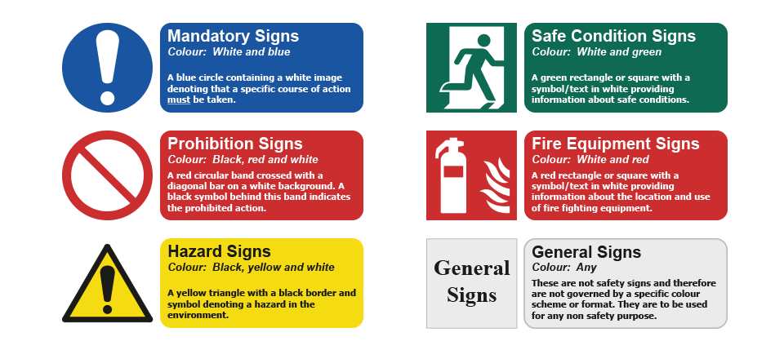
Development activity - familiarisation
Use Swim Safe pp slides 8 onwards. Can usually work out meaning of safety signs. If too complicated, no-one would take any notice and then get into dangerous situations. Have a go at working out what the signs might mean. Notice the shape and perimeter colour as this should also give a clue to meaning and therefore our response.

Main Activity – (Approx 15 minutes)
Use Swim Safe activity sheet p5 to match the signs to the meaning (see also answers).
Create own red/yellow sign on templates. Write on the back of the sign what our response should be if see eg no swimming. AA add explanation eg because...
Observation task – What can I see?
Have a look at partner’s signs. Are they easy to understand? | Ask the observer to look out for 2 things:  - Check perimeter colour is correct for the type of sign  - Check meaning clear  Share some observations.
Competition Time
Use Quiz Safety Signs sheet to recap. Go through and check matching safety sign sheet.
Plenary
Feedback on walt/wilf – thumbs for self-assessment  Next week learning about the SAFE CODE and how to avoid getting into difficulty. Tell your family what you have learnt about water safety. | Recap main points of lesson

