Y5 Water Safety Questionnaire
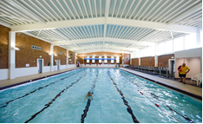
Question 1: At the swimming pool, who is the best person to tell you it is safe to swim? (Tick one box)
- Your mum, dad or carer
- A lifeguard
- Your teacher
- I don’t know

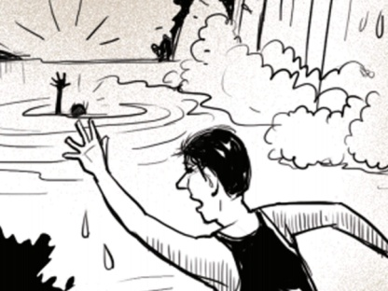
Question 2: If your friend fell into the canal, would you? (Tick one box)
- Shout for help
- Panic
- Jump in to save them
- I don’t know

Question 3: What do these signs mean? (Tick one box)
Sign 1:
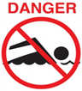
- You can swim
- No swimming allowed
- You can swim with armbands on
- I don’t know
Sign 2:
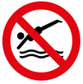
- You can dive in
- No diving is allowed
- Diving is ok if you don’t use your arms
- I don’t know
Question 4: Where’s the safest place to jump into a pool? (Tick one box)
- Shallow End
- Deep End at any time
- Deep End only if the lifeguards let me
- I don’t know

Question 5: Explain what these flags mean.

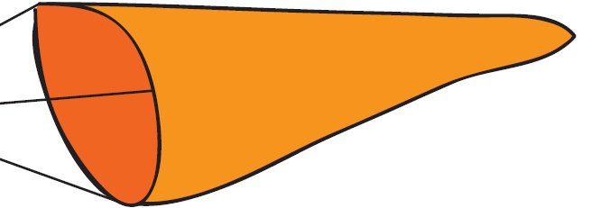

Question 7: What does SAFE stand for in the SAFE CODE?
S
A
F
E
Question 6: Who has taught you about water safety? (Tick the boxes you think are right)
- Parents/carers
- School Teacher
- Swimming Teacher
- No-one
Thank you for completing this questionnaire.

