Monday 3rd August 2020
Scarborough RNLI reveal missing boy, 10, had been swept out to sea

Scarborough's RNLI lifeboat crew have revealed that a 10-year-old boy who went missing in the town on Friday was in the sea for nearly an hour.
Scarborough South Bay
The boy was reported missing just after 7pm on Friday, when Scarborough's beaches were packed with crowds enjoying the hot weather. North Yorkshire Police later confirmed he had been found safe, but did not release any further details of the circumstances of the incident.
The RNLI have now put out a statement praising the boy's courage and presence of mind after he survived being in the sea for nearly an hour during which he was blown across the entire length of the South Bay (about 700m).
He adopted the position recommended by the RNLI for anyone who finds themselves in trouble in the water - floating on the back with arms and legs spread out - because he had watched a TV programme about sea rescues.
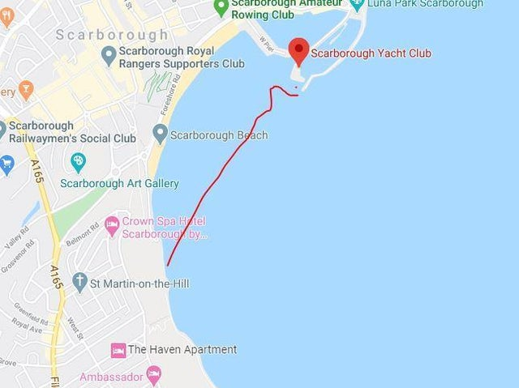The red line shows the approximate distance across South Bay the boy was blown when he was swept out to sea
He was finally found shouting for help near Vincent Pier, having been swept out to sea by the wind and tide near Scarborough Spa.
The RNLI launched their inshore lifeboat to assist police and Humber Coastguard with the search.
Scarborough coxswain Lee Marton said: "We were told that he’d been watching lifeboat rescues on the BBC documentary ‘Saving Lives at Sea’ and had followed the advice given on the show.
"We’re very much in awe of this incredible lad, who managed to remain calm and follow safety advice to the letter in terrifying and stressful circumstances. Had he not, the outcome might have been very different."
The boy was escorted to the lifeboat station where he was reunited with his family before being taken for a precautionary check-up at Scarborough Hospital by the Yorkshire Ambulance Service.
The RNLI advises anyone struggling in the water to float in a starfish position while awaiting rescue, as people often end up in more difficulty when trying to swim against the current.

