Meet Ravi
A 10-year-old boy who was swept out to sea during a day trip to the beach with his family has described how he feared he was going to die.

Ravi Saini (slide 1) survived for more than an hour using floating advice he had remembered from a BBC TV documentary.

Rescuers praised him when they found him on his back, with his arms and legs spread, shouting for help in the water near Scarborough (slide 2). "I felt like 'yeah I finally got a second chance to live'," said Ravi.

Ravi, from Leeds, had been at the beach in South Bay with his father, Nathu Ram, 37, his mother, Puspa Devi, 34, and his nine-year-old sister, Muskan. He thanked the lifeboat crew again for saving him while visiting the town's Lifeboat station (slide 3) on Thursday and described how he had been in the water with his father and sister when he suddenly realised he was out of his depth.

"I realised I was floating and I was like 'help me, help me'," said Ravi. "My dad tried to come but the water was higher than him."
"I was petrified and I thought that this was the end of my life," he continued. After what felt like "five hours" at sea, he said he heard the lifeboat's engine approaching. (slide 4)

Ravi, who has weekly swimming lessons, described being a fan of the BBC documentary Saving Lives At Sea, (slide 5) in which he saw the "Float to Live" technique of lying on your back, staying calm and spreading out like a starfish. "All of a sudden the waves were so strong that every single part of my body was covered by water."

His father, (slide 6) a chef, described how he tried to reach his son to rescue him but the water was too deep with strong currents. "The water was round my neck and I lost my control," said Mr Ram. "Slowly, slowly he was going too far. Once or twice we saw his face. After that we didn't see him. "When I was in the water I was struggling and I was thinking that we could both lose our lives." Going through his mind was the fear that his son might "die in front of my eyes", he added.

Lifeboat crewman Rudi Barman described Ravi as "an incredible young man" who "resisted the urge to panic". (slide 7) "The fact that he was on his back floating to live is just amazing really. That's what saved his life."

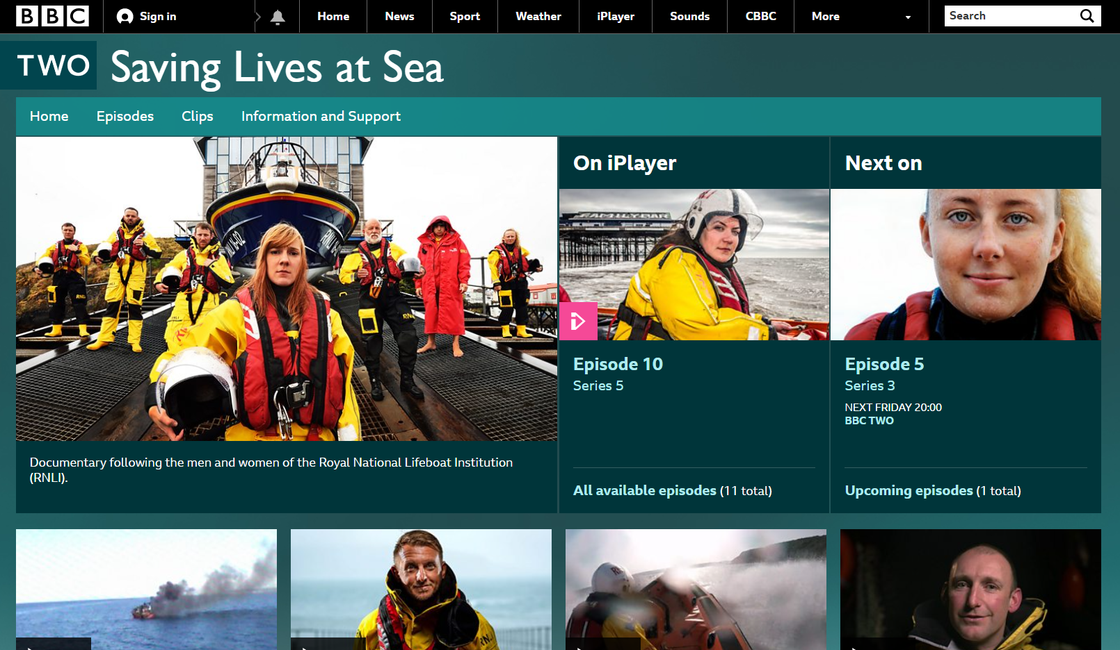

'Float to live' advice
- The "float to live" advice is a key message in the RNLI's national drowning prevention campaign, Respect the Water
- It urges people to follow potentially lifesaving advice if they find themselves in trouble after falling into cold water
- Fight your instinct to swim hard or thrash about - this can lead to breathing in water and drowning
- Instead, relax and float on your back until you have regained control of your breathing
- You can find more advice on the RNLI's website.

