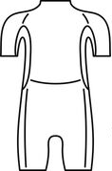
Design a wetsuit. Persuade a customer to buy your wetsuit by explaining the benefits of wearing the wetsuit in cold water.

