Falling in Cold Water

What's the risk?
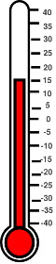
Anything below 15°C is called cold water and can seriously affect your breathing and movement, so the risk is significant most of the year.
Average UK sea temperatures are just 12°C. Rivers such as the Thames are colder - even in the summer.

What happens?
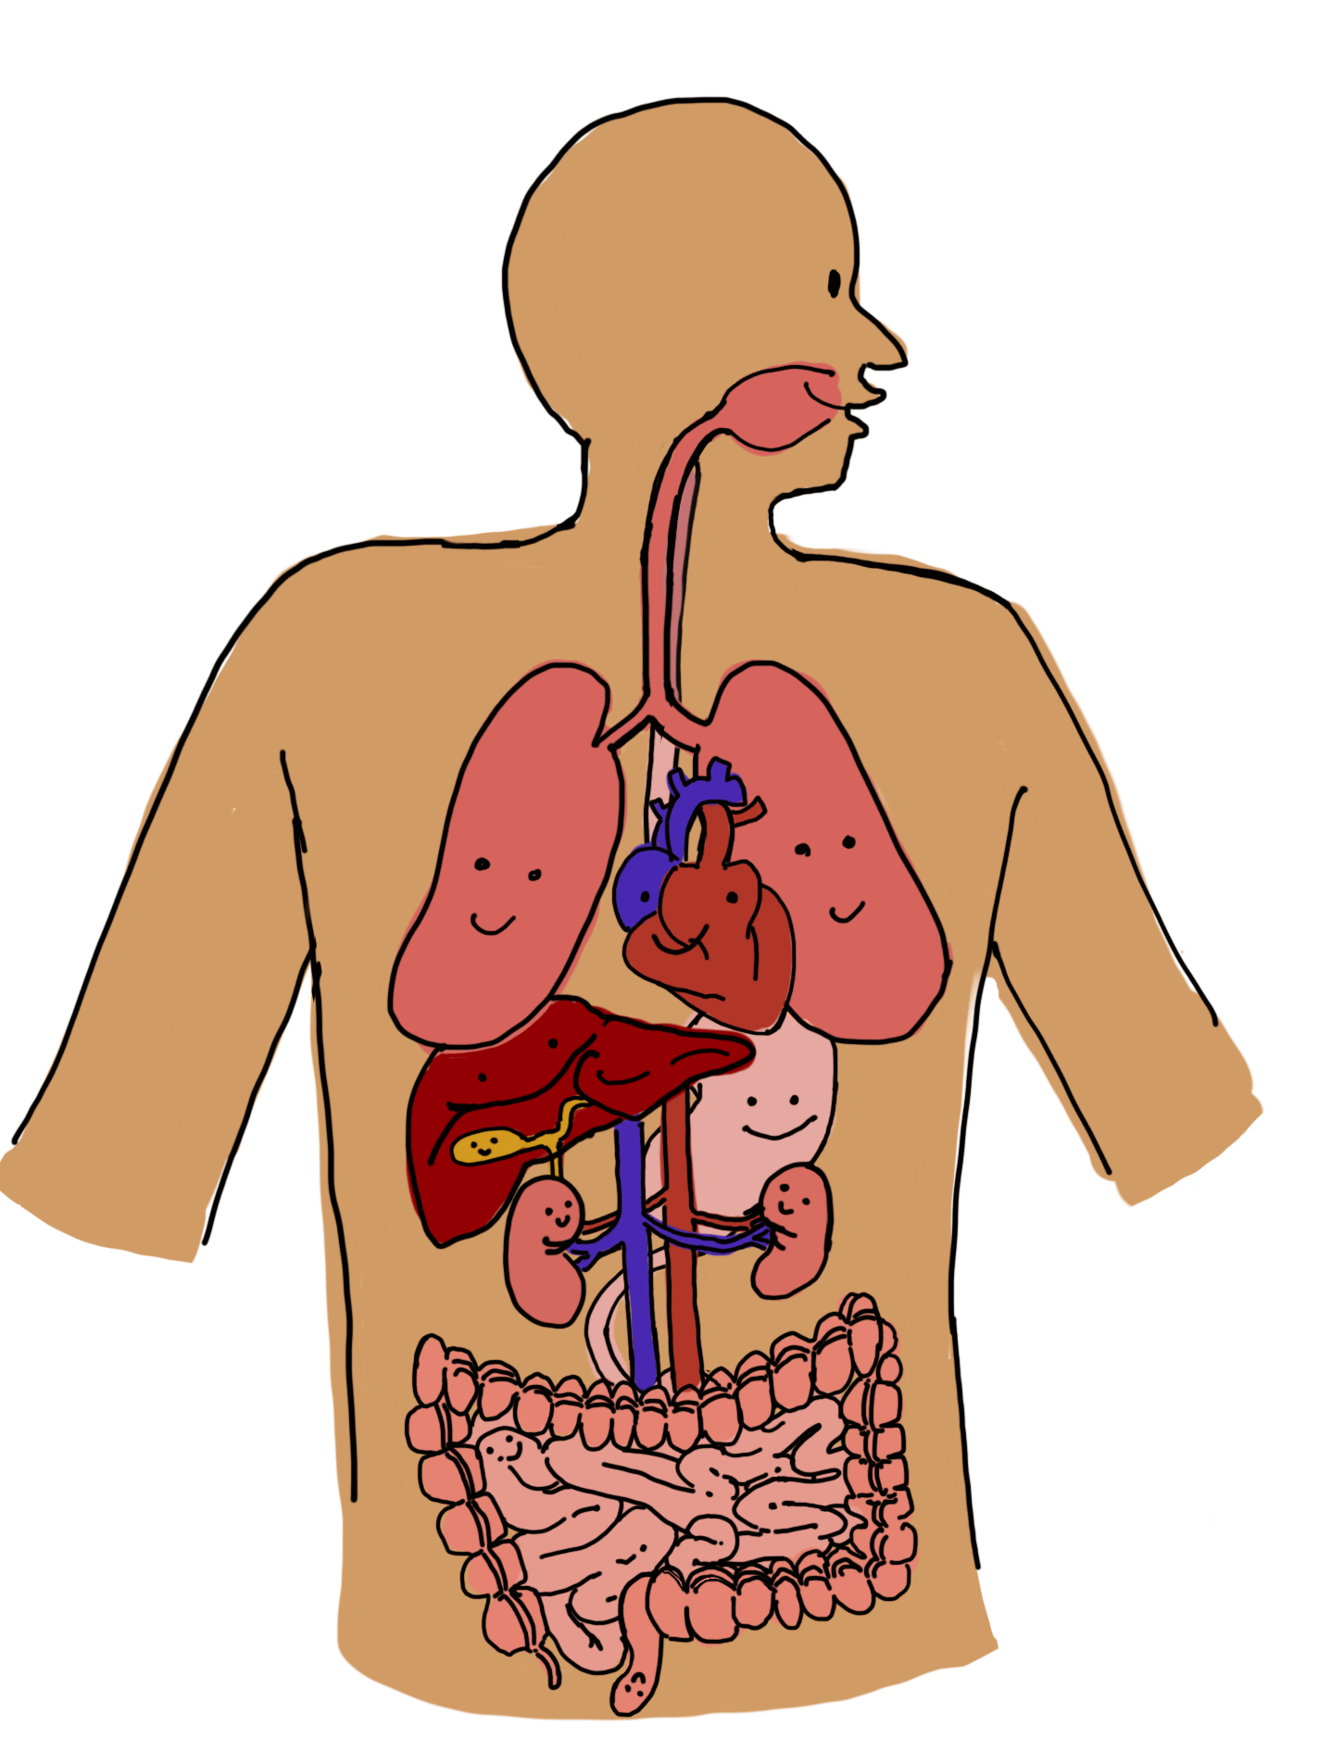
Something called Cold Water Shock happens to your body and brain. Cold water shock causes the blood vessels in the skin to close, which makes blood flow harder. As a result, the heart has to work harder and your heart rate and blood pressure go up. Cold water shock can therefore cause heart attacks, even in young, healthy people.
The sudden cooling of the skin by cold water also causes an involuntary gasp for breath. Breathing rates become uncontrollable, sometimes increasing as much as ten times faster. All these responses contribute to a feeling of panic, increasing the chance of inhaling water directly into the lungs.
This can all happen very quickly: it only takes half a pint of sea water to enter the lungs for a fully grown man to start drowning.

