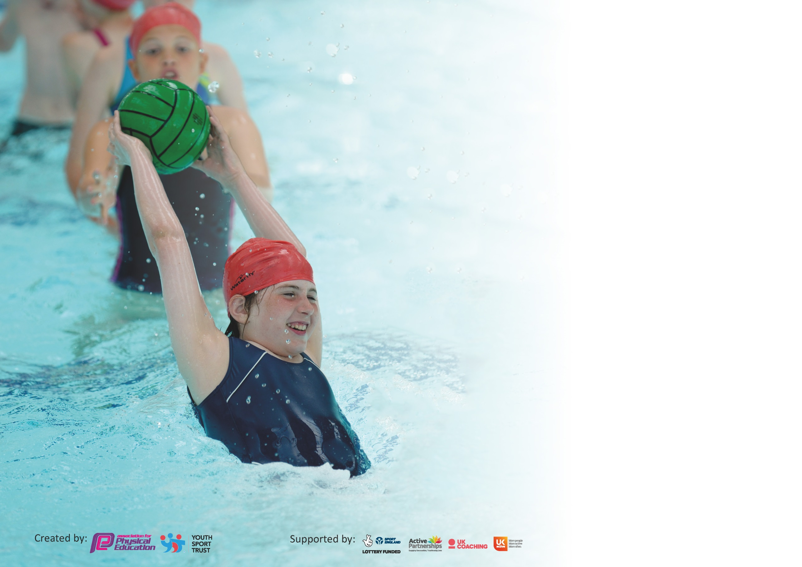

It is important that your grant is used effectively and based on school need. The Education Inspection Framework (Ofsted 2019 p64) makes clear there will be a focus on ‘whether leaders and those responsible for governors all understand their respective roles and perform these in a way that enhances the effectiveness of the school’.

Under the Quality of Education criteria (p41) inspectors consider the extent to which schools can articulate their curriculum (INTENT), construct their curriculum (IMPLEMENTATION) and demonstrate the outcomes which result (IMPACT).

To assist schools with common transferable language this template has been developed to utilise the same three headings which should make your plans easily transferable between working documents.

Schools must use the funding to make additional and sustainable improvements to the quality of Physical Education, School Sport and Physical Activity (PESSPA) they offer. This means that you should
use the Primary PE and Sport Premium to:

- Develop or add to the PESSPA activities that your school already offer
- Build capacity and capability within the school to ensure that improvements made now will benefit pupils joining the school in future years

Please visit gov.uk for the revised DfE guidance including the 5 key indicators across which schools should demonstrate an improvement. This document will help you to review your provision and to report your spend. DfE encourages schools to use this template as an effective way of meeting the reporting requirements of the Primary PE and Sport Premium.

We recommend you start by reflecting on the impact of current provision and reviewing the previous spend.

Schools are required to publish details of how they spend this funding as well as on the impact it has on pupils’ PE and sport participation and attainment by the end of the summer term or by 31st July 2020 at the latest.

We recommend regularly updating the table and publishing it on your website throughout the year. This evidences your ongoing self-evaluation of how you are using the funding to secure maximum, sustainable impact. Final copy must be posted on your website by the end of the academic year and no later than the 31st July 2020. To see an example of how to complete the table please click HERE.

Support for review and reflection - considering the 5 key indicators from DfE, what development needs are a priority for your setting and your pupils now and why? Use the space below to reflect on previous spend and key achievements and areas for development.

Key achievements to date until July 2020: | Areas for further improvement and baseline evidence of need:
- Continued to increase the number of children from all age groups participating in extracurricular activity  - Successfully included underrepresented groups in extracurricular activity, specifically those children with SEND  - Continued to build on previous success in attending and competing in a wide variety of competitions  - Successfully implemented opportunities for exercise across the school day e.g. daily mile  - Staff have continued to deliver the required 2 hours of PE lessons per week and targeted training has supported quality of provision  - Competed in virtual competitions during lockdown | - Continue to implement whole staff training, supporting staff in taking opportunities for greater activity across the school day  - Structured daily exercise session to be implemented across school  - NQT and new staff training  - To develop opportunities for children to engage in physical activities in the outdoors and during breaktimes (explore instillation of outdoor ‘gym’ equipment and training for staff)  - Continue to offer the opportunities for extracurricular and competitive sport

Meeting national curriculum requirements for swimming and water safety.
What percentage of your current Year 6 cohort swim competently, confidently and proficiently over a distance of at least 25 metres?  N.B. Even though your pupils may swim in another year please report on their attainment on leaving  primary school at the end of the summer term 2020. | 68.22% from a starting point of 2.57%
What percentage of your current Year 6 cohort use a range of strokes effectively [for example, front crawl, backstroke and breaststroke]? | 72.37%
What percentage of your current Year 6 cohort perform safe self-rescue in different water-based situations? | 97.2%
Schools can choose to use the Primary PE and Sport Premium to provide additional provision for swimming but this must be for activity over and above the national curriculum requirements. Have you used it in this way? | Yes/No

Action Plan and Budget Tracking
Capture your intended annual spend against the 5 key indicators. Clarify the success criteria and evidence of impact that you intend to measure to evaluate for pupils today and for the future.

Academic Year: 2020/21 | Total fund allocated: £18,000 | Date Updated: 01.09.20
Key indicator 1: The engagement of all pupils in regular physical activity – Chief Medical Officer guidelines recommend that primary school pupils undertake at least 30 minutes of physical activity a day in school |  |  |  | Percentage of total allocation:
 |  |  |  | 23.8 %
Intent | Implementation |  | Impact
Your school focus should be clear what you want the pupils to know and be able to do and about  what they need to learn and to  consolidate through practice: | Make sure your actions to achieve are linked to your intentions: | Funding allocated: | Evidence of impact: what do pupils now know and what can they now do? What has changed?: | Sustainability and suggested next steps:
- To provide more opportunities to ensure all pupils undertake 30 minutes of activity a day in school.  (e.g. you might include this as your research may have shown only 60% of pupils meet the CMO guideline of accessing 30 minutes of activity a day in school. Active Schools Planner may identify a range of ideas to address this issue)  - Encourage pupils to lead healthy life style out of school and engage in 30 mins a day  (e.g. you might include this as your research may have shown only 40% of pupils meet the CMO guideline of accessing 30 minutes of activity outside school)  - Improve opportunities for less active  (e.g. you might include this as your research may have shown a number of pupils do not access 30 mins of activity in or outside of school) | - Introduce 2 x 10-minute activity bursts during lessons throughout the day using Go Noodle & Cosmic Kids  - Introduce new playground markings and fixed equipment to improve break/lunchtime experience for pupils  - Introduce Daily Mile  - Introduce Active Homework tasks in each year group 1 x per week  - Promote Active Travel and introduce reward/sticker chart system in each class  - Introduce Change4Life Club for less Active Pupils with an aim of transitioning into the regular extra-curricular programme | £0  £3000  £0  £0  £300  £1000 Equipment and Coach
Key indicator 2: The profile of PESSPA being raised across the school as a tool for whole school improvement |  |  |  | Percentage of total allocation:
 |  |  |  | 21.9%
Intent | Implementation |  | Impact
Your school focus should be clear what you want the pupils to know and be able to do and about  what they need to learn and to  consolidate through practice: | Make sure your actions to achieve are linked to your intentions: | Funding allocated: | Evidence of impact: what do pupils now know and what can they now do? What has changed?: | Sustainability and suggested next steps:
- Introduce targeted programmes  (your whole school development plan may contain whole school KPI’s that you could link into your PESSPA offer e.g. Improve reading levels in girls in KS1, close the gap in maths attainment in pupil premium pupils)  - Introduce dedicated timetable of events throughout the year e.g. Health Week, Sports Day, Link with other subject areas such as Science week  (parents or pupil voice may have identified a desire for the introduction of health weeks or your whole school development plan may have a KPI around the development of Science based attainment for example)  - Promote PESSPA related achievements and opportunities regularly to school community  (this helps to evidence your PESSPA offer and promote your work across the whole school community) | - Introduce Active Maths and English (Purchase Teach Active)  - Introduce Active Play Through Storytelling for KS1  - Introduce a whole school ‘Health Week’ linked to other subject areas  - Re-develop sports day to introduce a participation element alongside the competitive side  - Introduce a termly sports newsletter  - Create a PE/Sports Twitter feed to celebrate successes  - Produce termly reports for head/governors  - Introduce a PE star of the week for each year group | £2000  £0  £1000  £200  £750 (cover time)

Key indicator 3: Increased confidence, knowledge and skills of all staff in teaching PE and sport |  |  |  | Percentage of total allocation:
 |  |  |  | 20%
Intent | Implementation |  | Impact
Your school focus should be clear | Make sure your actions to | Funding | Evidence of impact: what do | Sustainability and suggested
what you want the pupils to know | achieve are linked to your | allocated: | pupils now know and what | next steps:
and be able to do and about | intentions: |  | can they now do? What has
what they need to learn and to |  |  | changed?:
consolidate through practice:
- To provide CPD to staff to increase confidence and knowledge of staff  (your staff audit may have shown 70% of staff require support in gymnastics PE delivery for example)  - Strengthen the leadership of PESSPA in school  (you yourself as PE Coordinator may feel as though you require some support or development in your role)  - Introduce assessment in PE across all classes in school  (you may have identified from your observations and audit that staff are unsure about the developmental stages of pupils in relation to PE and progressions required in each year) | - Deliver inset gymnastics CPD  - Introduce gymnastics half term block of curriculum support for 30% of teachers identifying the need for support as a result of the staff audit  - PE Coordinator to enrol on SLUK Level 5/6 PE Coordinator CPD  - PE Coordinator to attend Sheffield PE Conference  - PE Coordinator to arrange 1-1 meeting with SSP lead  - Purchase Assessment in PE packs  - Provide Twilight CPD on Assessment for all staff | £300  £2340 (SSP bolt-ons)  £1000  Included in SSP Membership  Included in SSP Membership  Included in SSP Membership
Key indicator 4: Broader experience of a range of sports and activities offered to all pupils |  |  |  | Percentage of total allocation:
 |  |  |  | 22.6 %
Intent | Implementation |  | Impact
Your school focus should be clear | Make sure your actions to | Funding | Evidence of impact: what do | Sustainability and suggested
what you want the pupils to know | achieve are linked to your | allocated: | pupils now know and what | next steps:
and be able to do and about | intentions: |  | can they now do? What has
what they need to learn and to |  |  | changed?:
consolidate through practice:
- Provide a broad and balanced curriculum in PE lessons  (You may have identified that class teachers do not feel comfortable in planning a PE curriculum map)  - Provide a range of extra-curricular clubs including alternative activities  (Pupils or parents may have identified a range of new activities that you have not delivered previously. You may also have identified that less active pupils are interested in taking part in non-mainstream type activities)  - Develop children’s leadership opportunities  (Your school games mark application may have identified you need to engage more pupils in sports leadership/SSOC’s to achive ‘Gold’status) | - Introduce curriculum mapping document across whole school  - Purchase Get Set for PE Scheme of Work for whole school  - Introduce alternative extra-curricular activities to target less active pupils:  Handball, Tchouckball, Quidditch, Karate  - Provide opportunities for ALL pupils to lead in lesson times. Ideas provided to class teachers  - Develop SSOC  - Introduce playtime leaders rota for Y5 & Y6 on KS1 yard | £200 cover time  £1375  £2000 coaching costs  £0  £0  £500 equipment, bibs, whistles

Key indicator 5: Increased participation in competitive sport |  |  |  | Percentage of total allocation:
 |  |  |  | 11.3%
Intent | Implementation |  | Impact
Your school focus should be clear | Make sure your actions to | Funding | Evidence of impact: what do | Sustainability and suggested
what you want the pupils to know | achieve are linked to your | allocated: | pupils now know and what | next steps:
and be able to do and about | intentions: |  | can they now do? What has
what they need to learn and to |  |  | changed?:
consolidate through practice:
- Introduce an intra-competition calendar to provide competitive opportunities for ALL pupils  (You may have identified that the same pupils always attend competitions. You may wish to introduce a range of opportunities so that all pupils get a chance to take part in competitive sport. You might also have identified a whole school link to competitions through your house system if you have one in place)  - Enter a minimum of 6 inter-school competitions  (Your School Games application may have shown that to achieve Gold status, you need to enter a minimum of 6 inter competitions next year)  - Introduce personal best activities for pupils to set individual targets and achieve their own personal best  (Your School Games application may have shown that to achieve Gold status, you need to offer at least 2 personal best challenges each year. Equally, less active pupils may have said they are not interested in competitive opportunities which may lead to the introduction of personal best activities) | - Create an annual schedule of intra-competitions linked to the curriculum map  - Utilise the School Games Format Cards on the Your School Games Portal  - Link intra-competitions to house system  - Contact local SGO and sign up to School Games Competitions  - Subscribe to SSP Membership to access additional inter comps  - Subscribe to SFSS to access inter competitions  - Subsidise transport costs to events  - Utilise the Move More Physical Activity Challenge Packs which also provide a tracking and assessment opportunity. Ensure each class completes and registers results twice per year  - Promote Sheffield Get Moving Challenge  - Utilise sports leaders to create and deliver personal best challenges at lunch and break times | £0  £0  £0  2035  £1000 SSP membership  £2000  £0  £0  £0

Signed off by
Head Teacher:
Date:
Subject Leader:
Date:
Governor:
Date:

