**People Services: Service for Deaf and Hearing Impaired Children**

**Deaf Friendly Remote Learning: Good practice guide for schools.**

Online learning offers challenges and opportunities for all pupils, including those with hearing loss. This Checklist, based on advice from the National Deaf Children’s Society, provides some practical suggestions on the reasonable adjustments that you can make to help ensure that deaf children are not disadvantaged by any move to online learning.

**When planning remote online lessons think about**:

* Have you thought about how to meet the deaf pupil’s communication and support needs?
* Have you balanced pre-recorded or pre-formulated learning with face to face online learning?
* Does the pupil have the tools and resources they need to learn independently? If not, what support do they need to access learning in the same way as their peers?
* Are any online assessments accessible?

**Be deaf aware:**

* Is your communication style accessible to deaf learners? A simple test is to turn down the sound and ask a friend or colleague how easy it is to understand the content of your lesson or presentation.
* Make sure that when you are speaking your face is well lit and can be seen clearly. Avoid covering your face or mouth with your hands or turning away from the camera. Deaf children use visual clues as well as auditory information to help them learn.
* When reading a story, position yourself so that the deaf pupil can see the book/page and your face.
* Can the deaf learner still see your face when you are slide sharing?
* Does the deaf learner need to lip read and see your face at all times?
* Remember that live captions used over a prolonged period of time can be very tiring, so is there any other way you can provide key information prior to the lesson?
* Encourage deaf pupils to work from a suitable shared home location where there are low levels of background noise so they don’t miss vital information to keep them safe.

**Communicate clearly:**

* If appropriate, allow pupils access to lesson content or a lesson overview before the session, so they can familiarise themselves with new vocabulary and learning.
* Before you start speaking, make sure everyone has muted their microphones and that there is no background noise.
* Pace your lesson – talk slowly and clearly and build in natural pauses.
* Try not to deliver too much information too quickly, and avoid abrupt changes of pace or content.
* Use clear language and avoid jargon. Give explanations of new, unfamiliar or key vocabulary and repeat or show a written version of the word. Avoid drifting from the point!
* Make sure instructions are clear, supporting them with visual information if appropriate.
* Don’t ask students to complete a task whilst you are still talking.
* If children are fluent readers consider using closed captions, subtitles or live transcription.

**Break up content:**

* Chunk your lesson into clear sections.
* Avoid long periods with just you talking. Break up learning with different activities.
* Build in learning breaks – listening for long periods of time is very demanding on deaf pupils.

**Make group work accessible:**

Think about how you are going to include pupils in your activities and interactions by:

* making sure that classmates understand how to communicate effectively online
* making sure a pupil’s video is on before they speak so the deaf pupil can see their face
* asking one pupil to speak at a time and repeating or paraphrasing their answer
* using the chat function or creating a group chat.

**Use all available technology:**

* Check that deaf pupils are aware of the technology that might help them, for example, headphones, streamers and radio aids. Contact your teacher of the deaf if you need advice or support to use your streamer (e.g mini mic) or radio aid with your laptop, tablet or P.C. *See Appendices 1 and 2*
* Make sure that deaf pupils are aware of the accessibility options on your online learning platform, for example live captioning on Microsoft Teams or Google Classroom. *See Appendices 3 and 4*
* If you are showing video with audio content make sure that it is accessible through subtitles. Choose subtitles from the Settings menu on the video.
* Record your lesson and allow learners to access the recording so they can watch it back at their own pace.

**Use visual support**

* Use visuals such as objects, pictures and animations to support learning but don’t add in unnecessary visual information.
* Don’t clutter PowerPoint slides, and keep information clear and informative.
* If you are using new vocabulary in a presentation allow pupils to click on the word and read the meaning through a pre-populated glossary.

**Get feedback**

Seek feedback from your pupils. Ask questions about:

* how easy they found it to understand what they had to do
* the pace of delivery
* accessibility of images and videos

**Assessment**

Online assessments can be challenging for deaf pupils. Care must be taken so that pupils are not unfairly disadvantaged because they cannot understand what they are being asked to do. Here are some things to be aware of.

* If the assessment is not testing listening, then audio content could disadvantage the deaf pupil. If audio content is required – either to assess listening or because the child cannot read instructions easily, then consider using a live speaker or interpreter.
* Are instructions clear and straightforward? Is the language used familiar to the child? Are sentence structures simple with the most important information put first?
* Are the visuals helpful or misleading? Deaf pupils are more likely to seek information from visuals and could become distracted by competing information.
* Assessments can be stressful for all pupils but deaf pupils may become more anxious because of perceived or real difficulties accessing and completing tests. Make sure pupils feel well supported through careful preparation and planning.

**Additional information can be found on the National Deaf Children’s Society website:**

[**https://www.ndcs.org.uk/blog/deaf-friendly-remote-learning-a-checklist-for-teachers/**](https://www.ndcs.org.uk/blog/deaf-friendly-remote-learning-a-checklist-for-teachers/)

For more information or advice, please contact the Service or your named Teacher of the Deaf:-

Caroline Chettleburgh [Caroline.chettleburgh@sheffield.gov.uk](mailto:Caroline.chettleburgh@sheffield.gov.uk) Tel: 0114 273 6410

Rachel Dickens [Rachel.dickens@sheffield.gov.uk](mailto:Rachel.dickens@sheffield.gov.uk) Tel: 0114 273 6410

**Service for Deaf and Hearing Impaired Children**

**Floor 4, North Wing,**

**Moorfoot Building**

**Sheffield S1 4PL**

**Appendix 1 – Using a Radio Aid with a P.C, Lap top or tablet.**

The pupil’s Radio aid kit should contain a lead or “auxiliary cord”. Plug one end of the lead into the jack at the bottom of your radio aid transmitter, and the other end into the headphone jack or outlet on a desk top computer, laptop or iPad. Make sure that “input” is selected on the audio settings. Sound will then go directly from the device to the pupil’s hearing aids, so they do not need to wear headphones. Have a look at this YouTube video to help if you are unsure – the lead is shown towards the end

[Roger Touchscreen Mic - Video Guide - YouTube](https://www.youtube.com/watch?v=LAHE6dBb9Ys)

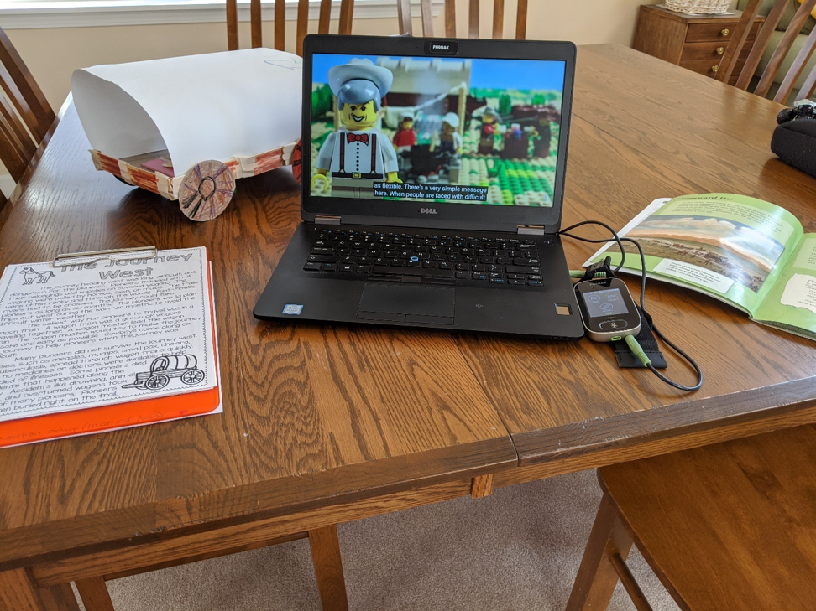

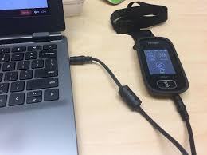

**Appendix 2 – Using Headphones**

When using headphones with hearing aids, choose a model that fits completely over the hearing aids’ microphone. If it doesn’t fit completely over, the hearing aid will pick up external sound instead of what is coming from the headphone. The key is to make sure the headphone speakers are located far enough away from the hearing aid microphones to prevent problems with audio feedback. Noise isolating or noise cancelling headphones are best.

Choose headphones that fit completely over the hearing aid if possible.



**Appendix 3 – Using Live Captions**

**Appendix 3 – Captioning Options**

On Microsoft Teams, to select auto captions, click on the 3 dots to select “More Options”. Click on “CC” to select live captions.

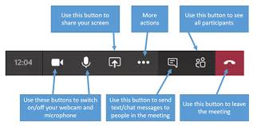

On Google Classroom, when you have created your slides, click on the closed captions option at the bottom.

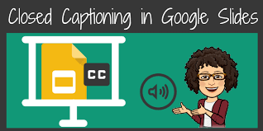

**Appendix 4 – Suppression of background noise on Microsoft Teams**

On Microsoft Teams, you can opt for a higher suppression of background noise. Click on your profile picture. In Settings, click on Devices. Click on Noise Suppression in the Menu, and select High.

