Runner Workbook

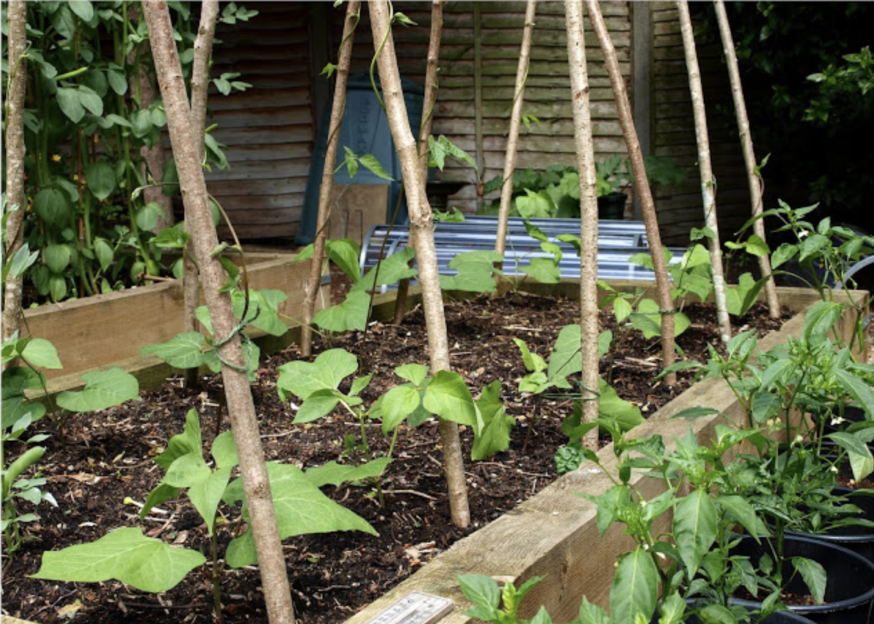

Name:

Objectives:

- To grow the biggest runner bean
- To calculate how much the plant has grown each week
- To make a meal with your runner beans

Runner bean competition



Task: You are going to plant your runner bean and complete tasks as it grows.

What you are going to need:

- Runner bean seeds
- Plant pot
- Soil

- Water

Method
- Take your plant pot and fill it ¾ full with soil
- Then take using your finger create a little hole
- Place your seeds in the hole
- Cover with soil
- Give them a water
- Place in a sunny spot to watch them grow

Tracking my bean plant

Week | Height | How much has it grown from the previous week?
1
2
3
4
5
6

To work out how much the plant has grown, minus the new reading with the old reading.
For example…

My plant was 2cm in week 2 and 5cm in week 3
To work out its growth do
5 – 2 = 3
So my plant has grown 3cm

The Bean Game

The child should begin by walking around a room in any direction, then on various commands of an adult carry out the appropriate action.

Command | Action
Jumping bean | Jump around the room
Runner bean | Run on the spot
Broad bean | Stretch your arms and legs out as wide as you can
Baked bean | Lay on the floor in a star shape until the next command is given
Jelly bean | Wobble like a jelly

Plant lifecycle
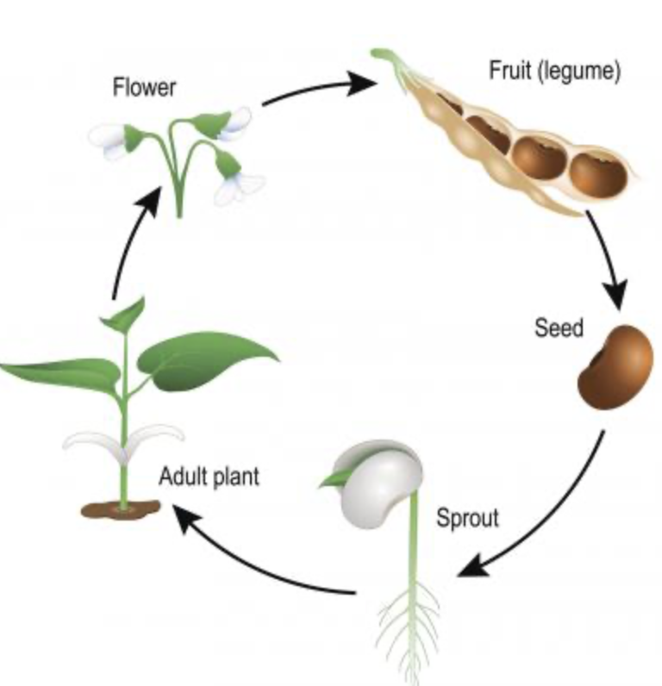

There are four stages in the life of a bean plant:

- The seed is in the capsule which the new bean is housed
- Germination is the process in which the baby plant emerges from the seed hull.
- Leaf growth begins when the seedling grows its true sets of adults.
- When flowers appear the plant has fully matured and your beans will start to grow.

What date did you see your runner bean sprout?

Watch this video to find out more https://www.youtube.com/watch?v=7a0u5jMYviM

Runner recipes

Can you think of any recipes which involve any types beans?

Here is an idea of what you could make with your beans

Runner bean pasta

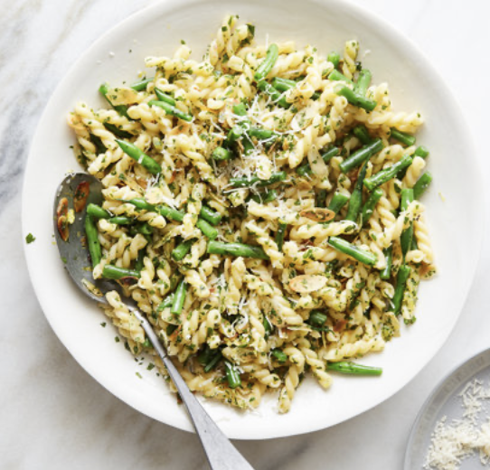
What you will need
- 400g pasta
- 400g green or runner beans
- 1 onion
- 4tbsp olive oil
- 2 cloves of garlic
- Zest and juice of a lemon
- 2 handfuls of mixed herbs
- 100g parmesan or other cheese
- Salt and pepper

Method
Step 1
With the help of an adult slice the runner beans diagonally into long strips
Step 2
Heat the frying pan and add the onions until they begin to soften
Step 3
Add the beans, garlic and herbs to the pan
Step 4
Leave to cook for 7 minutes
Step 5
Into a saucepan put in the pasta and water, leave to cook for 15 minutes
Step 6 add all the ingredients into one bowl and add the cheese
Then serve

Exploring my senses
Look at your runner bean and complete the 5 senses (do this task when plant has grown.)






