**My Mindful Eating  
Diary**

Name:

Class:

Texture

Smell

Sweet or salty?

Hot or cold?

Soft or crunchy?

Do I like it?

Taste

Appearance

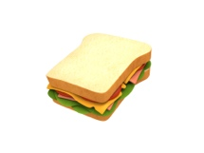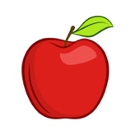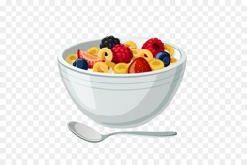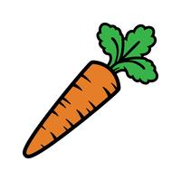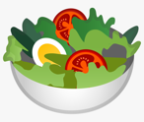

|  |  |
| --- | --- |
| Today’s date: |  |
| What am I eating today? |  |
| What does it look like? What colour is it? |  |
| What does it taste like? Is it sweet, or maybe salty? |  |
| What does it feel like?  Is it hard, soft, crunchy, smooth? |  |
| Does it have a smell? Does it smell nice? |  |
| Anything else I noticed… |  |

|  |  |
| --- | --- |
| Today’s date: |  |
| What am I eating today? |  |
| What does it look like? What colour is it? |  |
| What does it taste like? Is it sweet, or maybe salty? |  |
| What does it feel like?  Is it hard, soft, crunchy, smooth? |  |
| Does it have a smell? Does it smell nice? |  |
| Anything else I noticed… |  |