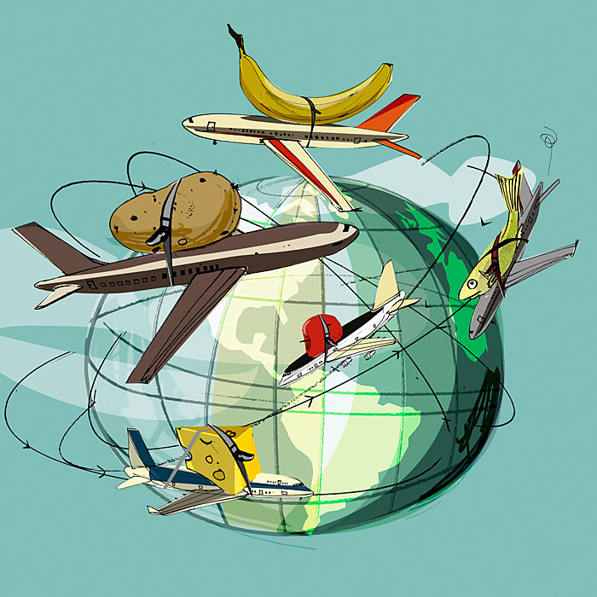Food Miles

Next time you go to the supermarket, investigate where your food has come from!

The back of the product tells you where the food has come from and fruit/vegetables should have signs or stickers that tell you where they were grown.

Activity: Choose 5 products, use the map provided and draw a line to where your food has come from.

Which product had the furthest journey to your plate?

