**Design a healthy lunch competition!**

On the empty plate, we want you to draw a delicious healthy lunch that you’d like to eat.

The tastiest, healthiest looking lunches will win and be displayed in school!

**Tips to help you get started…**

Your lunch should be nice and healthy, so instead of choosing chocolate or sweets for a snack, choose fruit and vegetables! They are delicious and will help you reach your 5-a-day ☺

You could draw apples, bananas, carrot sticks, cucumber… whatever you like!

Remember to add water on the side instead of fruit juice or milkshakes!

Try to make your plate really **colourful** with different coloured fruits and vegetables, like yellow bananas, green grapes and red strawberries – the more colourful the better ☺

**My healthy lunch:**

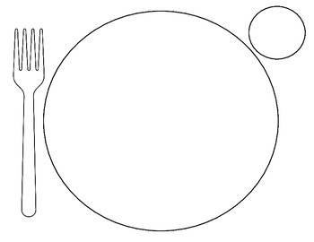

Name:

Class: